1. A sentinel value is a value that signifies the end of user data.
2. A)

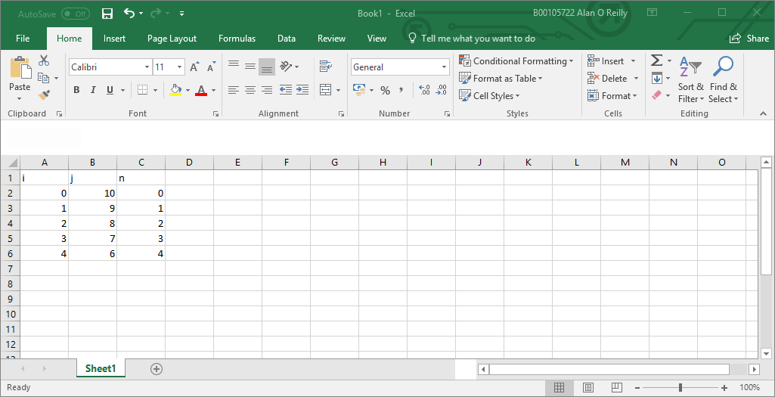

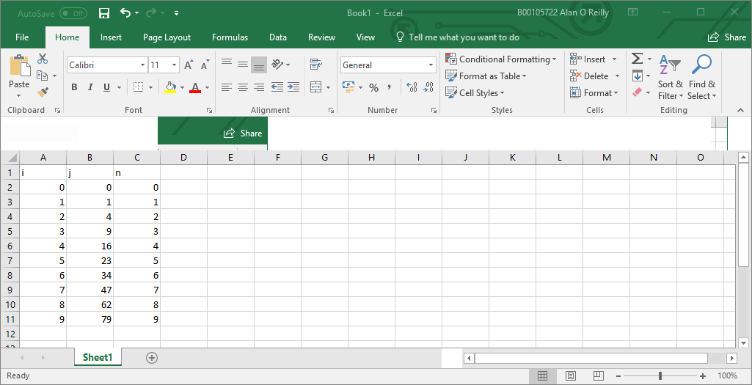B)

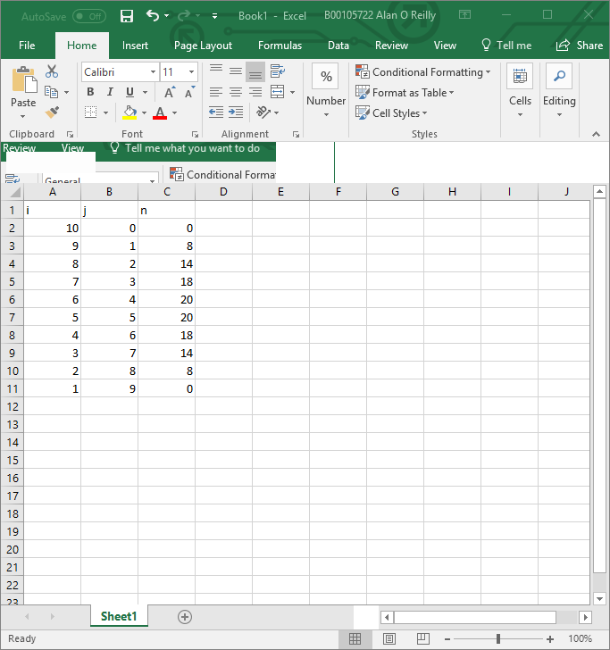C)

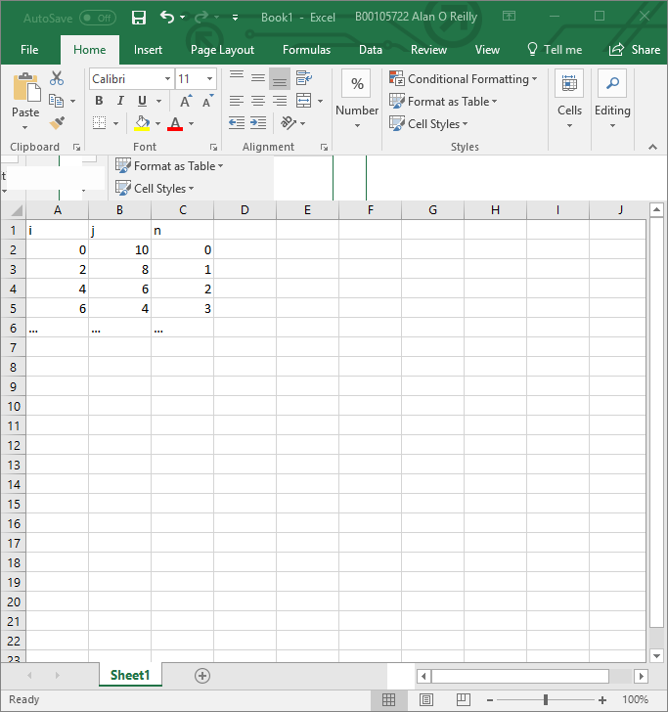D)

1. Counter-controlled repetition works by having a while loop that stops when the counter integer reaches a certain value
2. An infinite loop is one that the criteria for the loop stopping is never met or is non-existant
3. int counter = 2;

do{

System.out.println(counter);

counter += 2;

}while(counter<= 100);